**PIZZA SALES SQL QUERIES**

1. **KPI’s**
2. **Total Revenue**

**select sum(total_price)AS Total_Revenue from pizza_sales**

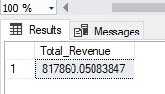

1. **Average order value**

**select sum(total_price) / count(distinct Order_id)as Avg_order from pizza_sales**

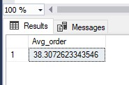

1. **Total Pizza sold**

**select sum (quantity) as Toatal_pizza_sold from pizza_sales**

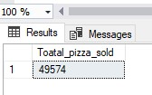

1. **Total orders**

**select count (distinct order_id) as Toatl_order from pizza_sales**

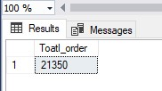

1. **Average Pizza Per order**

**select cast(cast(sum (quantity)AS decimal(10,2)) /**

**cast(count(distinct order_id)as decimal(10,2)) as decimal(10,2)) as avg_pizza_per_order from pizza_sales**

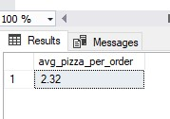

1. **Daily Trend**

select DATENAME(DW,order_date) as order_day,Count(distinct order_id) as Total_orders

from pizza_sales

Group by DATENAME(DW,order_date)

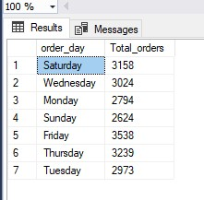

1. **Hourly Trend**

Select Datepart(hour,order_time) as order_hours,count(distinct order_id) as Total_orders

from Pizza_sales

Group by datepart(hour, order_time)

order by Datepart(hour,order_time)

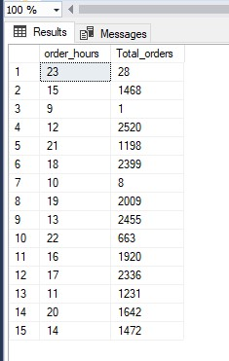

1. **% of pizza sales per category**

select pizza_category,sum(total_price) *100 /

(select sum(total_price) from pizza_sales where month(order_date) =1)As PCT

from pizza_sales

where month(order_date) =1

group by pizza_category

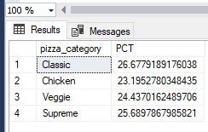

1. **% of sales per pizza size**

select pizza_size,sum(total_price) *100 /

(select sum(total_price) from pizza_sales where month(order_date) =1)As PCT

from pizza_sales

where month(order_date) =1

group by pizza_size

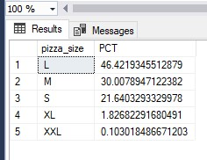

1. **Total pizza sold as per category**

select pizza_category,sum (quantity) as Total_pizza_sold

from pizza_sales

group by pizza_category

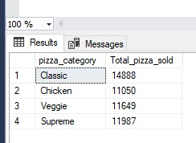

1. Top 5 Pizza sold

select top 5 pizza_name,sum(quantity)as Total_pizza_sold

from pizza_sales

group by pizza_name

order by sum(quantity) desc

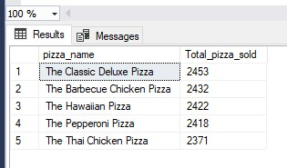

1. Worst pizza sales

select top 5 pizza_name,sum(quantity)as Total_pizza_sold

from pizza_sales

group by pizza_name

order by sum(quantity) asc

